Helpful link:

<https://e2e.ti.com/support/microcontrollers/c2000-microcontrollers-group/c2000/f/c2000-microcontrollers-forum/919623/launchxl-f28379d-newbie-can-communication-question>

Note CAN B is the one wired to the transceiver out of the launchpad. CAN A would need another transceiver wired.

CAN example from that doc:

<http://www.ti.com/lit/sprace5>

Also, Code Composer Studio has a number of examples, demos, and resources to get started. Look under View→Resource Explorer

Our board is the “LAUNCH 28379D” although that may be too specific. The general family is the C2000 series. There are a series of “intro” examples in the “C2000” series.

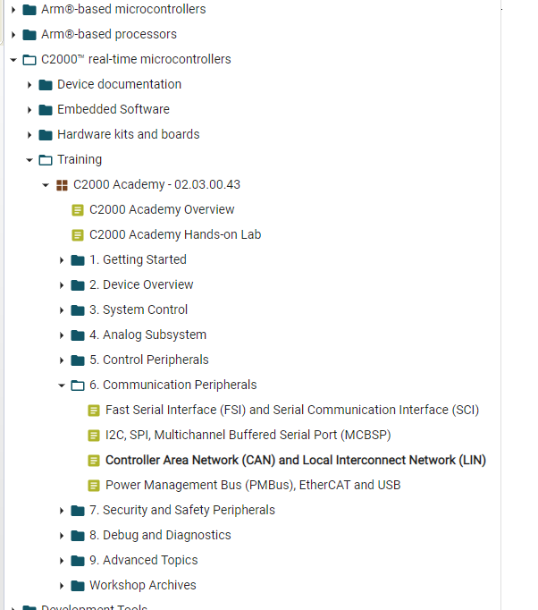



I created a simulink file that auto-generates code for a variety of the interfaces you might use. It will blink lights, flip GPIO bits, send PWM, and communicate through various interfaces. It was created in Matlab 2021a. Use caution with other versions, it is possible to use a newer version to open it, but then you must “export to previous version” to allow someone else to use it unless you all have the same version. If you are going this route, best practice would be to pick a matlab version and all use the same thing.

“Simulink_example_CAN_Serial1.slx”

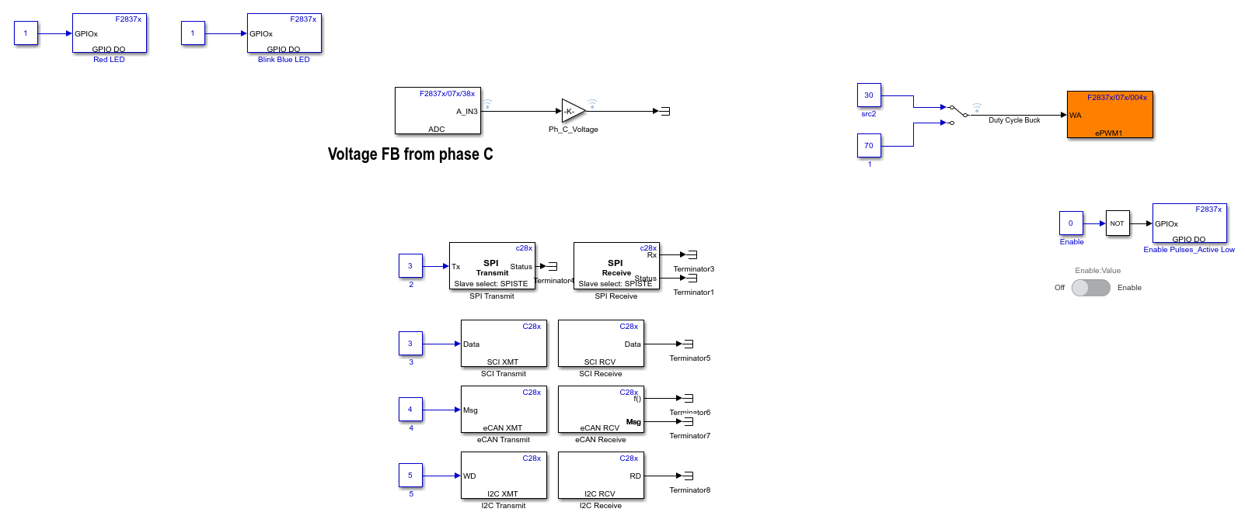

The process is this: it takes those blocks and their settings and creates the associated C-function calls, which it passes to TI Code Composer. So you can inspect the C-code just to see what it does.The code generation report is in this file and has clickable links to the various .c and .h files:

“Simulink_example_CAN_Serial1_codegen_rpt.html”

It is in folder:

\Electrical & Controls\Simulink_coder_example\Simulink_example_CAN_Serial1_ert_rtw\html